BULLDOG HOLIDAYS
2019
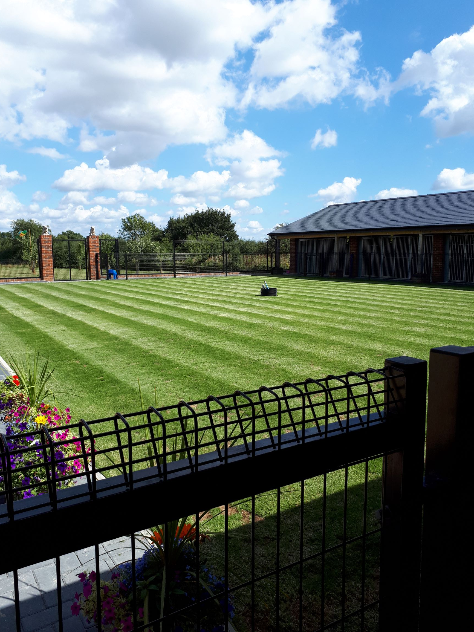

Bulldog holidays, Hillplace Kennels, The Mount, Ifield Wood, Crawley, RH11 0LF
Email bulldogholidays@aol.com tel 07796 805167 or 07801 592234
OPENING HOURS 8AM UNTIL 4PM
Bank details Bulldog holidays Ltd sort code 20 45 45 acc 13589072
Bulldog Holidays, is a state of the art luxury boutique hotel built specifically for the bulldog. Each suite has been built using the best products available on the market, the floors are tiled for coolness and hygiene but also have underfloor heating when needed (knowing how much our breed love their comforts) Glass panel doors so your bulldog can see everything going on. High ceilings and good natural light. The view from each suite is breath taking. We supply raised beds and lots of nice cuddly blankets for our guests. We know all the bulldog tricks so all blankets are checked and changed daily if needed just in case someone has wet the bed! Meals are included in the package and lots of treats too. We use Skinners complete food, Skinners duck and rice, skinners fish and rice, Skinners puppy food and also raw food. We know bulldogs inside out and a daily check and face wash making sure all those little creases and crevices are clean and powdered. We have beautiful fields also play areas (Splash pool in the summer) for daily use for your dog and as we have owned bulldogs for almost 30 years, we know how much exercise a bulldog should have and you can rest assured your bulldog is never going to be put at risk with heat or over exercise. We are very security conscience and someone is at the property 24 hours a day, the kennels have modern fire alarms fitted. Our love for this breed has lead us to build this facility to give the very best we can for these dogs, you can rest assured your dog is loved and cared for while you are away. We are able to take in Frenchies or other brachycephalic breeds providing they are purebred and not unrecognised colours (i.e. black, black and tan, blue, lilac, chocolate or merle due to the poor breeding practices used to produce these colours that are not in the breed). If your dog lives with another breed, we may be able to board it, please ask and we are happy to chat. Our charges are per day that the dog stays. 2019 , A NON RETURNABLE DEPOSIT OF £50.00P IS PAYABLE AT TIME OF BOOKING. FULL PAYMENT 14 DAYS BEFORE STAY.
£21.00 + vat = £25.20 for a single dog per day
£35.00 + vat = £42.00 for two dogs per day sharing a kennel (from same household)
Bulldog Beauty Parlour, Bath, nail trim, top and tail pamper is £24.00 + vat = £28.80
Nail trim £5.00 + vat = £6.00
Pick up or drop off at Crawley train station £15.00 + vat = £18.00 each way
Transport to vet £20 + vat = £24.00
Bank holidays a charge of £5.00 plus vat = £6.00 per suite applies
DOGS NAME TEMPERMENT? GOOD BAD
COLOUR AGE
MICROCHIP NUMBER
MALE/ FEMALE NEUTERED YES /NO
DATE OF LAST INOCULATION? PLEASE BRING THE INOCULATION CERTIFICATE
ANY MEDICAL PROBLEMS WE NEED TO KNOW? NORMAL FOOD USED?
OWNERS NAME ADDRESS
EMAIL TEL NOS
EMERGENCY TEL NOS
VET DETAILS
DATE AND TIME OF ARRIVAL
DATE AND TIME OF DEPARTURE Bath & Groom? YES / NO
Terms and conditions
A non-returnable deposit of £50.00p is payable at time of booking Bulldog Holidays sort code 20 45 45 acc13589072
NB Bookings will not be accepted without the deposit. Full payment 14 days before stay.
Please give at least 7 days’ notice of cancellation in writing or email, otherwise the whole fee is due, if you return home before the booked collection date, then we are afraid the full amount will still be due.
For dogs sharing a kennel, a disclaimer will have to be signed in case the dogs fight and if they do we, reserve the right to separate them and charge for single kennels.
If a dog is unwell it will be taken to our vet and the owner is responsible for the vet bill and £ 20 charge plus vat for each time it is transported to the vet.
We are open from 8 am until 4 pm every day, we may be able to open outside of those hours (within reason) but a £15 plus vat charge is payable.
A charge of £5 plus vat is payable on all bank holidays, Xmas and New Year per day.
We are closed for pick-ups and drop offs on Xmas day and new year day.
Please make sure your dog is fully inoculated and please bring the inoculation certificate with you, please note the kennel cough inoculation must be done at least 14 days before boarding if done any closer to boarding date WE CAN NOT BOARD YOUR DOG!
We take the bulldogs purity and health very seriously, therefore we do not accept unrecognised colour dogs or crossbred dogs that use the name bulldog. Owners signature

